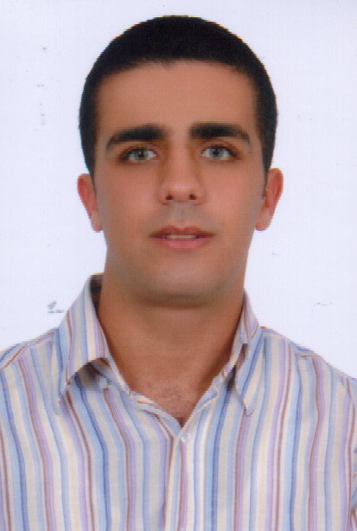
Samir SEMAAN
28/05/1985
Lebanese
Breij - Jbeil
Saint Charbel Street
03 – 155937
samir_seman@hotmail.com
Single
___________________________________________________________________________

Objectives: __________________________________________________________________

Looking for a challenging position that meats both my professional skills and my education in a well known organization.

Education: __________________________________________________________________

2003- February 2009: university Saint - Esprit kaslik
Diploma in computer communication engineering.

Summer of 2005: MTC Achrafieh
Diploma of up keeping and repairing computers (hardware and software)

2001 – 2003: Saint Rosary School
Diploma: SG (general science)

Professional experience: _______________________________________________________

February 2009 till present:
- Nokia Siemens Networks SSS department.( contracter)
Summer of 2008:
- Training in the transmission department from august 15 until September 15 2008 at LBC.
- Training in the SSS (switching sub-system) department from 31 July until 30 September 2008 at Nokia Siemens networks.

Summer of 2007:
- training in the technical and IT departments from august 15 until September 30 2007 at LBC.

Summer of 2006:
- Dalia phone Jbeil
Repairing and up keeping the network

2001 till present:
- Private lessons in Math Physics and Chemistry in both languages English and French.

Interests: ____________________________________________________________________
Sports: swimming, cycling, skiing, ping pong.
Chief in a scout
Member of a Christian assembly

Computer skills: ______________________________________________________________
Microsoft Word, Excel, Power Point, Access.
HTML, C++, Visual basic, UNIX, SQL, Math lab, Java script, Oracle, NS, PHP, Java.

Additional skill: ______________________________________________________________
Good working knowledge of English and French
Capable of making presentation

References: __________________________________________________________________

Mazen Kadi  Service Core Engineer  CMO MEA Care SLI CC Comp.Stream  Mazen.kadi@nsn.com  Mobile +961 3 722 387  Phone +961 1 963 933  Fax +961 1 963 801 | Dr. Ing. Joumana Farah  Chef du Département d’Ingénierie  Faculté des Sciences et de Génie Informatique  Université Saint-Esprit de Kaslik  B.P. 446 Jounieh, Liban  joumanafarah@usek.edu.lb  +961.9.600906

